3. Execute and display the results for the following commands in Kali Linux Operating Systems:
1. Tree
2. Head
3. Tail
Aim
To execute and display the results of basic Linux commands such as tree, head, and tail in the Kali Linux operating system.
1) Tree Command
Meaning: The tree command is used to display the directory and file structure in a tree-like format.
Output:
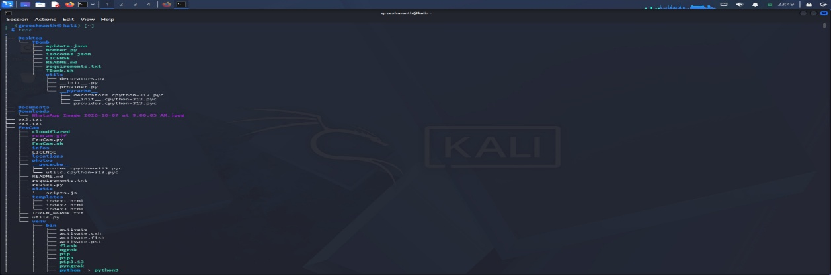
2) Head Command
Meaning: The head command is used to display the first 10 lines of a file by default.
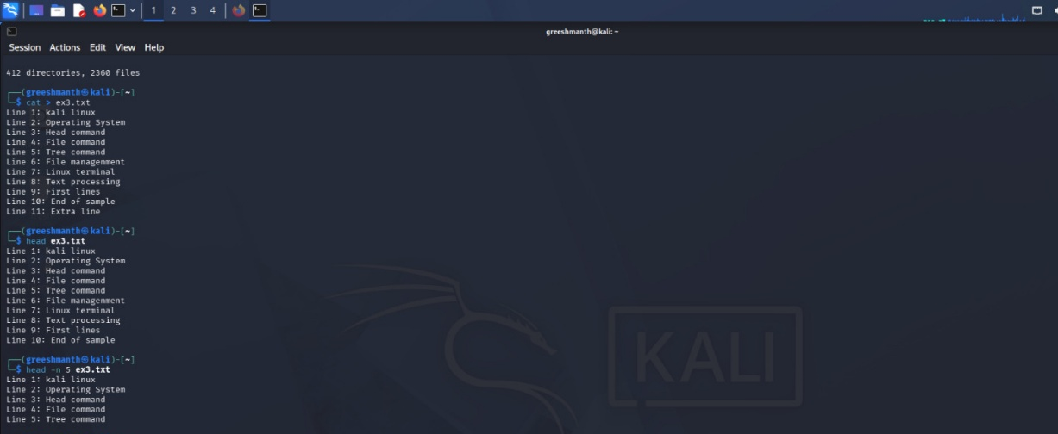

3) Tail Command
Meaning: The tail command is used to display the last 10 lines of a file by default.
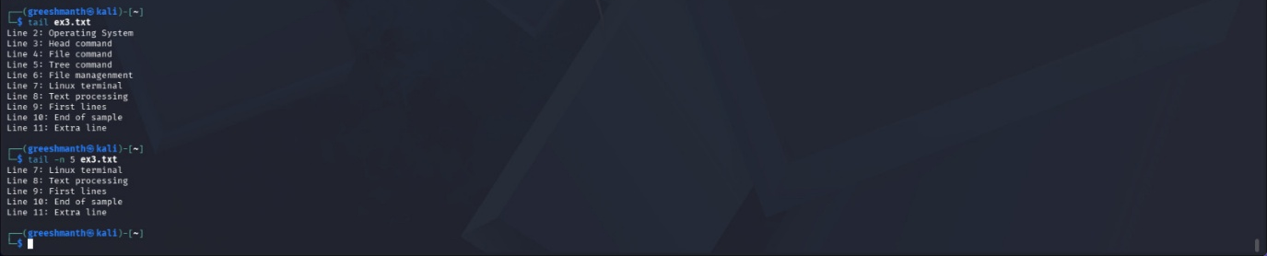

Result:
Thus, the tree, head, and tail commands were executed in the Kali Linux operating system, and their results were displayed.

